Given the head of a linked list, return *the list after sorting it in ascending order*.

Example 1:

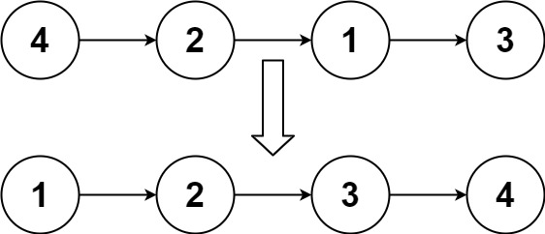

Input: head = [4,2,1,3]

Output: [1,2,3,4]

Example 2:

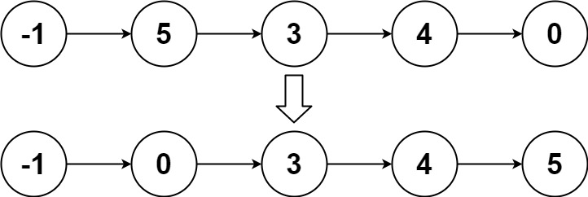

Input: head = [-1,5,3,4,0]

Output: [-1,0,3,4,5]

Example 3:

Input: head = []

Output: []

Constraints:

* The number of nodes in the list is in the range [0, 5 \* 104].
* -105 <= Node.val <= 105

Follow up: Can you sort the linked list in O(n logn) time and O(1) memory (i.e. constant space)?